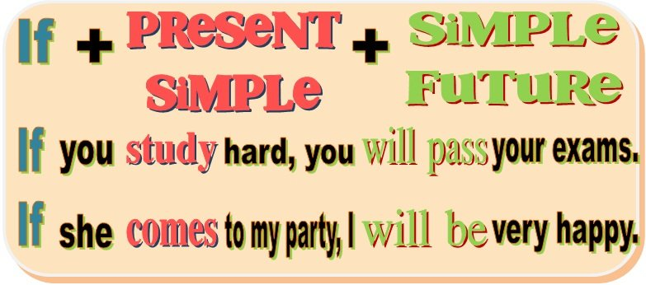
FIRST CONDITIONAL
(exercises)
1) Match the sentence halves.
1. I’ll be disappointed if you don’t come to the party.
If you eat too much, I’ll be disappointed

if it doesn’t rain tomorrow I’ll be happy

if I pass my final exam you’ll feel unwell

I’ll phone you If you pay for dinner,
We’ll go to the park If I need your help,
I’ll pay for lunch if you don’t come to the party

2._I’ll be happy if I pass my final exam
__
3.I’ll pay for lunch if you pay dinner.

4. I’ll phone you if I need your help

5. We’ll go to the park if it doesn’t rain tomorrow

6. You’ll fell unwell if you eat too much
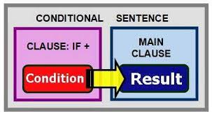

2) Choose the best answer, a or b.

1. If I find the book you want, I’ll send you a text message.
a) I’ll definitely find the book ()b) I might find the book (X)
2. If the tickets are too expensive, Sam won’t buy them.
a) Sam might buy the tickets (X)b) Sam will definitely buy the tickets
3. I’ll tell Jane the news if she comes to the party.
a) Jane might come to the party (X) b) Jane’s definitely coming to the party
4. John’s parents will give him a car if he passes the exam.
a) He might have a carb) He’ll definitely have a car (X)

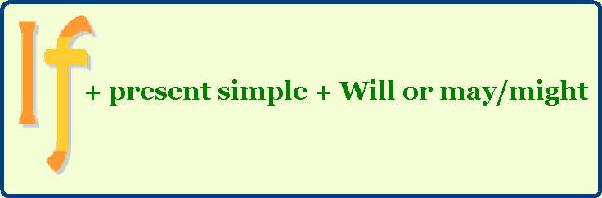

3) Complete these superstitions
1. If a cat washes (wash) behind its ears, it’ll rain (rain).
2. If the bride makes (make) her own dress, it’ll bring (bring) bad luck.
3. You’ll catches (catch) a cold if a cat sneezes (sneeze) three times.
4. If you open (open) an umbrella indoors, it ‘ll bring (bring) bad luck.
5. Something bad will happen (happen) to you if you walk (walk) under the ladder.
6. If you take (take) the last piece of bread on the plate, you’ll be (be) unlucky.
7. If you have (have) an itchy nose, you will have (have) an argument with someone soon.

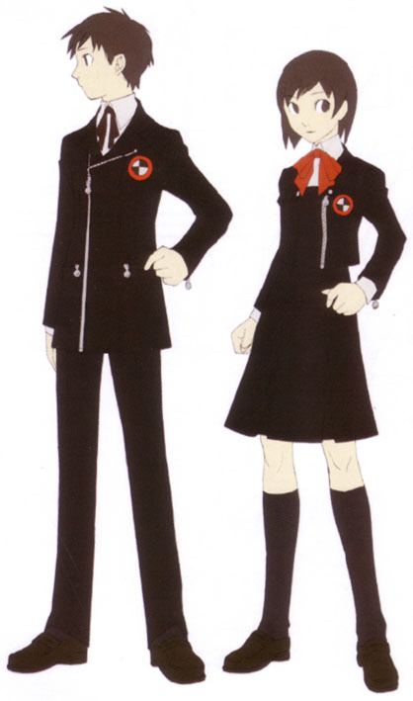
4) Complete the first conditional sentences with your own ideas.
1. I’ll be happy if I get a job_
2. If it rains all weekend, I’ll go watch a movie.
3. If I forget my best friend’s birthday, They’ll remind me with blood in eyes_____________
4. I’ll pass all my exams if study hard every day_________________________________
5. If I don’t feel well tomorrow morning, I’ll take a medicine
6. I’ll go to bed early if I will have class tomorrow morning___________________________
7. I’ll be disappointed if lie to me_______________________________________

KEY

Ex.1)
2. If you eat too much, you’ll feel unwell.
3. We’ll go to the park, if it doesn’t rain tomorrow.
4. I’ll be happy if I pass my final exam.
5. If I need your help, I’ll phone you.
6. If you pay for dinner, I’ll pay for lunch.

Ex.2)
1. b 2. a 3. a 4. a

Ex.3)
1. washes / will rain
2. makes / will bring
3. will catch / sneezes
4. open / will bring
5. will happen / walk
6. take / will be
7. have / will have

Ex. 4)
Students ‘own answers

